Driven by the results of ISIP™ Assessments and guided by research and frequent skills-based measurements, Istation Reading places students seamlessly into high-interest, interactive, online instruction. Designed to supplement classroom instruction, Istation Reading provides students with intervention, additional practice, and extension activities. Engaging instruction is delivered on a needs-based path for students in pre-K through middle school to ensure that each student’s needs are met.

As students progress through Istation Reading, they engage with a variety of texts across genres and with increasing complexity. Struggling students receive reteach lessons, and teachers are given instant Priority Reports to monitor student progress. Each Priority Report directs teachers to specific skills-based, small-group lessons for targeted intervention. Additionally, each instructional cycle contains multiple teacher-directed lessons for further instructional differentiation and support.

Cycles 1-7 focus primarily on building foundational skills necessary to learn to read with fluency and understanding. Purposeful scaffolding provides struggling learners with the support needed for reading success.
The foundational cycles of instruction include:
- Phonological/Phonemic Awareness
- Alphabetic Principle
- Phonics
- Book and Print Awareness
- Oral Language and Vocabulary Development
- Comprehension
- Fluency

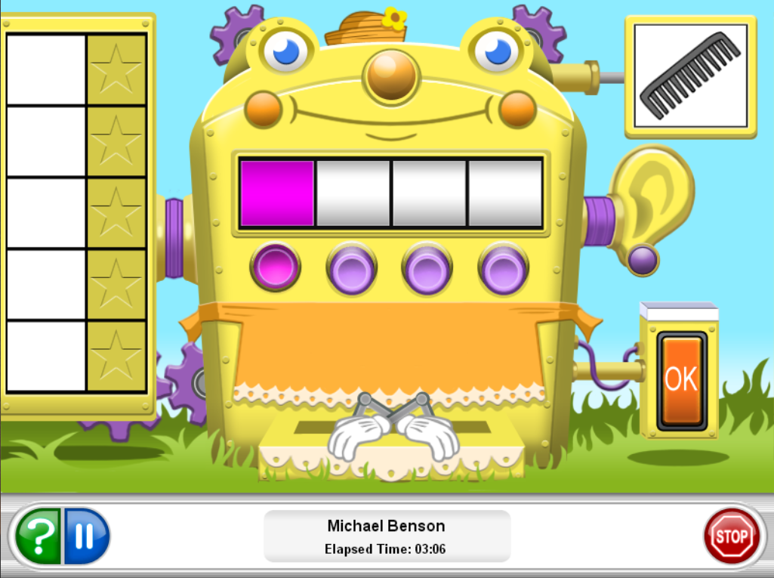

After Cycle 7, the focus shifts to more sophisticated phonics skills and comprehension strategy lessons that guide students in interacting with text across a variety of genres. At this level, students learn word analysis skills to decode multisyllabic words and vocabulary strategies such as using context to determine the meaning of an unknown word. As learners progress in the curriculum, they expand their vocabulary by building words with affixes and exploring Latin and Greek roots. Content-specific science and social studies vocabulary is also introduced in conjunction with content-area reading instruction in Cycles 12-14.
Cycles 8-15 include:
- Comprehension
- Word Analysis
- Fluency
- Vocabulary

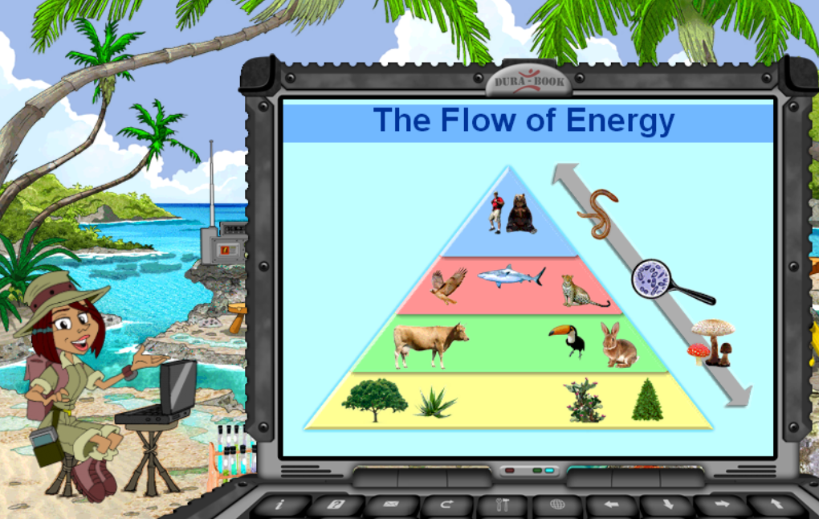

Istation Reading Cycle Descriptions
Foundations/Pre-Reading: (Pre-K)  - Alphabet  - Alphabetic Principle  - Phonological and Phonemic Awareness  - Letter Formation  - Book and Print Awareness (BPA)  - Embedded Vocabulary | Cycle 0  - Print Concepts  - Aural Patterns and Environmental Sounds  - Onset and Rime  - Identification of Initial, Medial, and Final Phonemes  - Isolation of Initial Phoneme
Cycle 1  - Letters – M, A, P, C  - Sound/Symbol – M, A, P, C  - Letter Formation: Mm, Aa, Cc, Pp  - Short Vowel /a/  - Segmentation and Blending of Phonemes  - Isolation of Initial Phonemes  - High-Frequency Words – and, the, see, has  - BPA  - Reading with Meaning  - Story Sequencing  - Character Descriptions | Cycle 2  - Letters – T, I, S, L  - Sound/Symbol – T, I, S, L  - Letter Formation: Tt, Ii, Ss, Ll  - Short Vowel /i/  - Segmentation and Blending of Phonemes  - Identification of Initial, Medial, and Final Phonemes  - Cumulative Letter and Sound Review  - High-Frequency Words – this, is, his, go  - Read with Meaning  - Decodable Connected Text  - Character Analysis  - Story Setting  - The sequence of Story Events
Cycle 3  - Letters – R, O, N, D  - Sound/Symbol – R, O, N, D  - Letter Formation: Rr, Oo, Nn, Dd  - Short Vowel /o/  - Long Vowel Pattern /ai/  - Long Vowel Pattern /oa/  - Initial Consonant Blends  - Final Consonant Blends  - Blending of Sounds to Create Nonsense and Real Words  - Identification of Initial, Medial, and Final Phonemes  - Cumulative Letter and Sound Review  - High-Frequency Words – here, are, you, they  - “I” and “a” as Words in Connected Text  - BPA: Punctuation  - Read with Meaning  - Reading Comprehension  - Story Setting  - Story Characters | Cycle 4  - Letters – F, E, H, G  - Sound/Symbol – F, short E, H, G  - Letter Formation: Ff, Ee, Hh, Gg  - Short Vowel /e/  - Long Vowel Pattern /ee/, /ea/  - Consonant Blends  - High-Frequency Words – my, where, with, to  - Rapid Letter and Word Naming  - BPA: Punctuation  - Read with Meaning  - Reading Comprehension  - Cause/Effect  - Story Structure  - Setting  - Characters  - Sequence
Cycle 5  - Letters – B, U, J, W  - Sound/Symbol – B, U, J, W  - Letter Formation: Bb, Uu, Jj, Ww  - Short Vowel /u/  - Consonant Blends  - Silent e  - Long Vowel Pattern a_e  - Long Vowel Pattern o_e  - Cumulative Letter and Sound Review  - High-Frequency Words – what, said, for, her  - Vocabulary  - Read with Meaning  - Reading Comprehension:  - Cause/Effect  - Simple Story Structure  - Setting  - Characters  - Sequence | Cycle 6  - Letters – Z, K, V, Y  - Sound/Symbol – Z, K, V, Y  - Letter Formation: Zz, Kk, Vv, Yy  - Consonant Blends  - Silent e  - Long Vowel Pattern i_e  - Long Vowel Pattern u_e  - High-Frequency Words – was, that, from, she  - Rapid Letter and Word Naming  - Long Vowel Review  - Cumulative Letter and Sound Review  - Phonetic Spelling  - Vocabulary  - Read with Meaning  - Reading Comprehension  - Main Idea and Supporting Details (Nonfiction)  - Problem/Solution  - Simple Story Structure  - Cause/Effect  - Setting  - Characters  - Sequence  - Informational Text Characteristics
Cycle 7  - Letters – Q, X  - Sound/Symbol – Q, X  - Letter Formation, Qq, Xx  - Initial Consonant Blends  - Soft C  - Soft G  - R-Controlled Vowel /ar/ as in far  - R-Controlled Vowel /ar/ as in share  - R-Controlled Vowel /or/  - Long Vowel Open Syllable /o/, /e/, and y  - Cumulative Letter and Sound Review  - Compound Words  - High-Frequency Words – do, come, there, have, of, some  - Rapid Letter and Word Naming  - Vocabulary  - Read with Meaning  - Reading Comprehension:  - Compare/Contrast Characters  - Setting  - Sequencing  - Making Simple Predictions  - Persuasive Text Characteristics | Cycle 8  - R-Controlled Vowel /er/ with Spellings er, ir, and ur  - Long i  - Long u  - Auditory Discrimination and Letter Naming  - Phonogram: -ng  - Digraph /sh/  - Digraph /th/  - Compound Words  - High-Frequency Words – does, your, when, could, give, want  - Vocabulary  - Read with Meaning  - Reading Comprehension
Cycle 9  - Diphthongs /oi/ and /oy/  - Digraphs /ch/ and /tch/  - Long Vowel Open Syllable  - Inflected Endings: -s, -ed as in looked, and -ing  - Two Vowels Go Walking: ay, oe, ie, ey  - Variant Vowels: ow as in snow – oi, oy, ol  - High-Frequency Words – who, goes, put, why, because, thought  - Rapid Word Naming  - Multisyllabic Words  - Read with Meaning  - Reading Comprehension:  - Cause/Effect  - Problem Solution | Cycle 10  - Digraph: ph  - Diphthong /ou/  - Inflected Endings: -s, -ed as in started and hummed, and -ing  - Variant Vowels: Words with au, aw, ow as in cow, ou, alk, all, and alt  - Open Syllable Words  - Schwa Sound at Beginning of Decodable Words  - Y as long e, as in baby  - High-Frequency Words – good, many, their, too, would, look  - Multisyllabic Words  - Vocabulary  - Read with Meaning  - Reading Comprehension:  - Character Analysis Using Web  - Compare/Contrast  - Sequencing Plot  - Problem/Solution
Cycle 11  - Variant Vowels: Words with /oo/ as in zoo, new, suit, glue, and as in foot  - Phonograms: igh, eigh, and ea for short e  - Vowel Patterns: ind and ild  - Inflectional Endings: Change y to i and add -es or –ed.  - Multisyllabic Words with Cumulative Review  - Contractions  - Synonyms and Antonyms  - Affixes  - Homophones  - Read with Meaning  - Reading Comprehension:  - Inferencing  - Main Idea/Details  - Cause/Effect  - Sequencing  - Compare/Contrast  - Informational Text Characteristics  - Argumentative Text Characteristics  Cycle 11B  - Genres World with Flint Rockwell  - Folktales  - Fables | Cycle 12  - Comprehension Skills  - Author's Purpose  - Cause and Effect  - Compare and Contrast  - Drawing Conclusions  - Inferences  - Main Idea  - Predicting Outcomes  - Representing Text  - Sequence  - Summarization  - Text Structure  - Vocabulary  - In Context  - Structural Analysis Using Affixes
Cycle 13  - Comprehension Skills  - Author's Purpose  - Compare and Contrast  - Drawing Conclusions  - Main Idea and Details  - Predicting Outcomes  - Problem/Solution  - Sensory Language  - Summarization  - Vocabulary  - Analogies  - Context Clues  - Homophones  - Multiple Meaning Words  - Synonyms and Antonyms  - Word Analysis  - Complex Word Families  - Structural Analysis Using Affixes | Cycle 14  - Comprehension Skills  - Author's Purpose  - Compare and Contrast  - Fact/Opinion  - Main Idea and Details  - Predicting Outcomes  - Sensory Language  - Summarization  - Text Structure  - Vocabulary  - Analogies  - Context Clues  - Idioms  - Multiple Meaning Words  - Synonyms and Antonyms  - Word Analysis  - Complex Word Families  - Structural Analysis Using Affixes
Cycle 15
- Comprehension Skills
  - Author's Purpose
  - Compare and Contrast
  - Drawing Conclusions
  - Main Idea and Details
  - Predicting Outcomes
  - Problem/Solution
  - Summarization
  - Text Structure
- Vocabulary
  - Analogies
  - Context Clues
  - Multiple Meaning Words
  - Synonyms and Antonyms
- Word Analysis
  - Complex Word Families
  - Spelling
  - Structural Analysis Using Affixes

